Memorandum of Understanding
Between
City of Albany and 1415 Washington Property, LLC

Statement of Purpose

The purpose of this Memorandum of Understanding (“MOU”) between the City of Albany (“City”) and 1415 Washington Property, LLC (“Applicant”) is to set forth the obligations, responsibilities, and commitments of the Applicant to fund its fair share component of the cost of certain pedestrian safety infrastructure to be installed by the City as more fully set forth in this Memorandum.

Background

In 2018, the City of Albany, along with the Capital District Transportation Authority (CDTA), sponsored a study entitled “The Washington Avenue/Patroon Creek Corridor Study”. The purpose of this study was to pursue complete streets improvements and design modifications for the Washington Avenue corridor between Fuller Road and Brevator Street consistent with the then newly adopted 30 mph speed limit as well as changing land uses along this corridor. The final study was presented in April 2019. The final Plan recommended numerous improvements along the corridor to enhance and increase pedestrian safety. These recommendations included construction of enhanced pedestrian crossings in areas of high pedestrian demand. The Plan also recommended that the City and its partners work proactively to identify funding sources for improvements to be installed.

In 2020, the Applicant submitted an application to the City for land use approvals to allow for the construction of a 560+/- bed private student dormitory to be located at 1415 Washington Ave, a parcel located within corridor study area. Both the City and Applicant agree that the proposed project will result is significantly higher numbers of pedestrians seeking to cross Washington Ave to access the SUNY campus. Discussions between the Applicant’s engineers and the City’s Traffic Engineering Department have identified certain types of pedestrian safety infrastructure that, if installed in proximity to the project property, will serve to provide an enhanced level of pedestrian safety protection for persons crossing Washington Ave. to access the SUNY campus.

This MOU sets forth the Applicant’s responsibility for funding the identified required pedestrian safety improvements to be installed in proximity to 1415 Washington Ave.

The Applicant and the City, along with their respective traffic professionals, have determined that the appropriate safety infrastructure to be installed to adequately protect pedestrians in the vicinity of both the Applicant’s project is installation of a full traffic signal. A Schematic Plan is forth in Exhibit “A” hereto. The Cost estimate for the installation of these Improvements is Two Hundred Eighty Eight Thousand Six Hundred Dollars ($288,600.00) and is attached hereto as Exhibit “B”. This cost estimate includes the following items: survey and stakeout, mobilization, work zone traffic control, excavation and disposal, traffic signal hardware and install, signing and striping, granite curbing, sidewalk ramps, landscaping (including topsoil and seed), embankment in place, contingency, and design/construction inspections.

Responsibilities of the Parties

The Applicant agrees to provide funding in the amount of One Hundred Percent (100%) of the estimated cost for the City to install the full traffic signal at the location shown upon the plans attached hereto as Exhibit “A”. This payment responsibility shall constitute a portion of Applicant’s efforts to mitigate the potential for adverse environmental impacts that could result from its private student housing project. Payment of these funds shall me made to the City prior to the issuance any building permits for the Applicant’s project.

The parties understand and agree that payment of these funds to the City shall fully satisfy the Applicant’s obligations pursuant to this MOU and actual installation of infrastructure or contracting for such work shall be the responsibility of the City. The timing of the installation of the infrastructure shall be at the discretion of the City. In no event shall issuance of a Certificate of Occupancy for Applicant’s project be tied to the timing of the infrastructure installation.

Modification

Either Party may propose modifications to this MOU. Modifications must be in writing and executed by authorized representatives of the parties hereto.

Effective Date and Duration

This MOU shall be effective upon execution by the parties and shall remain in full force and effect until such time that the Applicant has provided the aforementioned costs to the City.

Dated: _____________, 2021 Dated:_____________, 2021

City of Albany 1415 Washington Property, LLC

By:_____________________ By:_____________________

_____________________ _____________________
Print Name Print Name

____________________ ___________________
Title Title

STATE OF NEW YORK }
COUNTY OF________ }ss.:

On this ____ day of___________ 2021, before me, the undersigned, a notary public in and for said state, personally appeared____________________ personally known to me or proved to me on the basis of satisfactory evidence to be the individual whose name is subscribed to the within instrument and acknowledged to me that he executed the same in his capacity, and that by his signature on the instrument, the individual, or the person upon behalf of which the individual acted, executed the instrument.
____________________________________
Notary Public

STATE OF NEW YORK }
COUNTY OF________ }ss.:

On this ____ day of___________ 2021, before me, the undersigned, a notary public in and for said state, personally appeared____________________ personally known to me or proved to me on the basis of satisfactory evidence to be the individual whose name is subscribed to the within instrument and acknowledged to me that he executed the same in his capacity, and that by his signature on the instrument, the individual, or the person upon behalf of which the individual acted, executed the instrument.
____________________________________
Notary Public

EXHIBIT A

Schematic Plan Full Traffic Signal

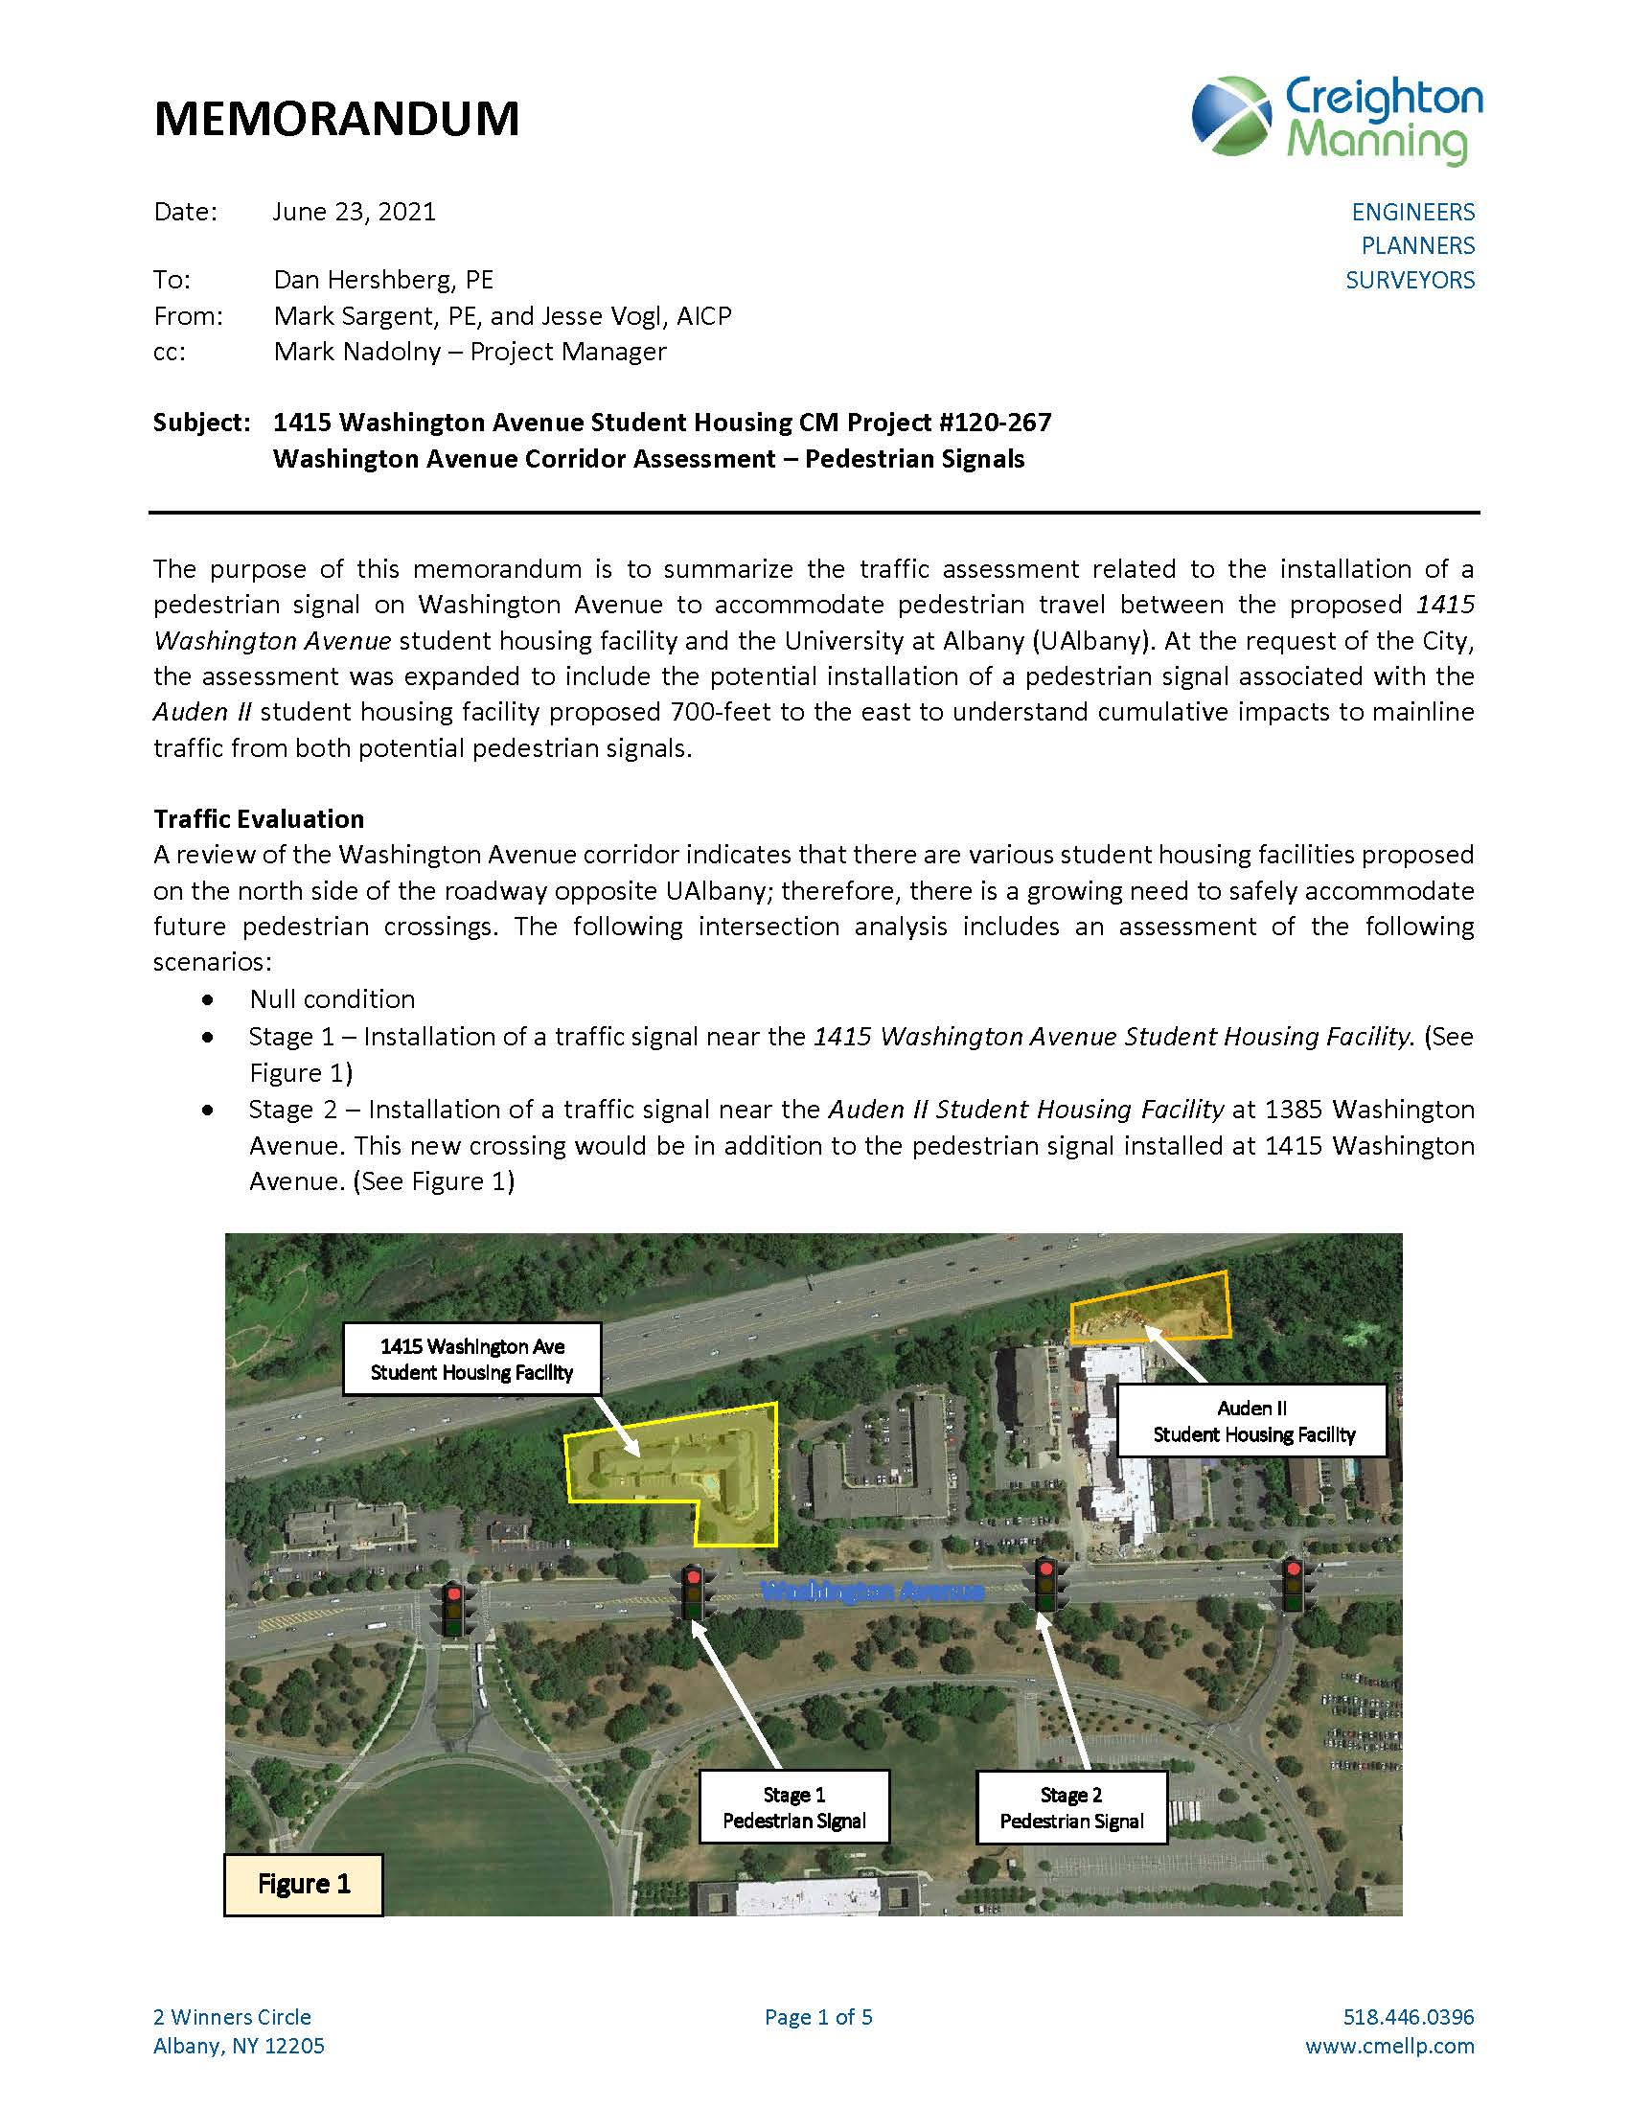

Location of Signals

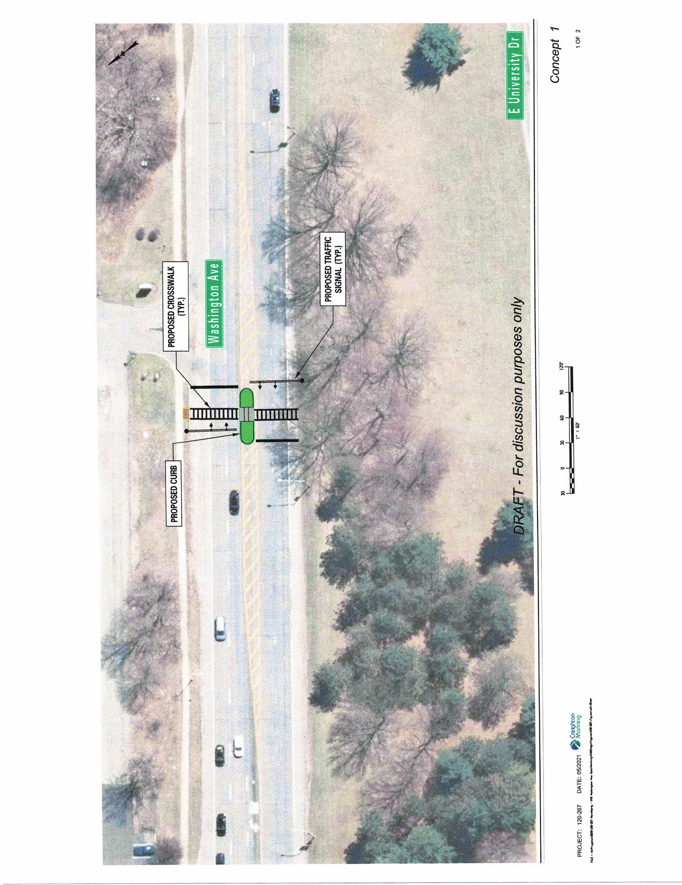
Signal Layout for 1415 Washington Avenue

EXHIBIT B

Cost Estimate

